Suturing

Objectives
At the end of the session the students will:
- Understand the difference between a simple interrupted, simple continuous and a subcuticular suture.
- Demonstrate the appropriate use of suture instruments (needle holder, scissors, forceps).
- Describe the different types of suture needles.
- Describe the indications for local anesthetics.
- Demonstrate the proper technique for a simple interrupted, simple continuous and a subcuticular suture.
- Demonstrate the proper technique for suture removal.

Indications
Suturing is the joining of tissues with a needle and suture so that the tissues bind together and heal. Suturing is required for most trans-cutaneous injuries. The functions of sutures are to close dead space, stop bleeding, support and strengthen wounds until healing increases their tensile strength, and approximate skin edges for an aesthetically pleasing and functional result.

Contraindications
Wounds should NOT be sutured if they are infected or have not been thoroughly debrided of necrotic tissue.

General Principles
- The choice of suture technique depends on the type and anatomic location of the wound, the thickness of the skin, the degree of tension, and the desired cosmetic result. The proper placement of sutures enhances the precise approximation of the wound edges, which helps minimize and redistribute skin tension. Wound eversion is essential to maximize the likelihood of good epidermal approximation. Eversion is desirable to minimize the risk of scar depression secondary to tissue contraction during healing. Usually, inversion is not desirable. Poorly sutured wounds heal more slowly and have an increased risk of bad result in an individual with a propensity for hypertrophic scars. The elimination of dead space, the restoration of natural anatomic contours, and the minimization of suture marks are

also important factors to optimize the aesthetic and functional results.

Equipment/Instruments
- Suture kit
- Needle Holder: used to grab onto the suture needle
- Forceps: used to hold the tissue gently and grab the needle
- Suture scissors: used to catch the stitch from the rest of the suture material
- Lidocaine
- Sterile saline
- Syringe
- Needle
- Sterile gauze
- Suture
- Adhesive tape

Types of Needles - There are two broad classifications of needles: curved and straight.
- Curved: Must be handled with forceps and a needle holder. More preferred needle for suturing. There are two types of curved needles: cutting and tapered.
  - Cutting needle: Used primarily for suturing the skin. It has a very sharp tip with sharp edges which are needed to pass through the skin.
  - Tapered Needle: “Round bodied” needles. Tapered needles have a sharp tip with smooth edges and are less traumatic to the surrounding tissues. Used primarily on the deeper, subcutaneous tissues, blood vessels, and intestinal anastomoses. A tapered needle is not good for skin suturing because it is difficult to pass the tapered needle through the skin.

- Straight: A straight needle can be used without instruments. Cumbersome and entails a much higher risk of accidentally sticking yourself. Uncommon and not recommended if curved needles are available.

Suture Sizes
- Sutures come in various sizes. The bigger the number, the smaller the size of the suture. Suture sizes range from 00 (very large, used to close the abdominal wall) to 10-0 (very tiny, used for microvascular anastomoses). You will generally use sizes in the middle range: 3-0 to 5-0.
- It is best to use small sutures on the face, such as a 5-0 or 6-0. Smaller sutures are associated with decreased scarring. On most areas of the body a 3-0 or 4-0 is appropriate. It is best to use smaller sutures on children due to their delicate skin.

Types of Suture Material
There are many types of suture material available. The two main classifications are absorbable or non-absorbable. Sutures can be further broken down into braided or non-braided.
- Non-absorbable Sutures
Remain in place until they are removed. They are less tissue-reactive and leave less scaring as long as they are removed in a timely manner. They are best used on skin.
- Absorbable Sutures
Dissolved by the body’s tissues. Do not need to be removed. Primarily used under the skin where they are well hidden. Tend to leave a more pronounced scar when used on the skin.
- Braided Sutures
Made up of several thin strands of suture material twisted together. Easier to tie than non-braided sutures, however they have little interstices in the suture material where bacteria can hide and grow. This may result in skin infections.
- Non-braided Sutures
A monofilament single strand. Recommended for most skin closures, especially wounds at risk for infection.

Handling of Instruments
- Scissors: Place your thumb and ring finger in the holes. Cut with the tips of the scissors to avoid accidentally injuring any surrounding structures or tissue.
- Needle Holder: If the driver is ratcheted, grab the needle until the clasp engages, ensuring that the needle is securely held. The needle holder is tightened by squeezing it until the first ratchet catches. The needle holder should not be tightened excessively because damage to both the needle and the needle holder may result. The needle is held in place by the needle holder in the middle third, with the tip pointing upward. Incorrect placement of the needle in the needle holder may result in a bent needle, difficult penetration of the skin, and/or an undesirable angle of entry into the tissue. Grab the suture needle with the needle holder: never handle the suture needle with your fingers.
- Forceps: Hold the forceps like a pencil. Be careful not to grab the skin too hard. It is best to grab the dermis or subcutaneous tissue- not the skin- with the forceps. The tissue must be stabilized to allow suture placement. Depending on the one’s preference, toothed or untoothed forceps or skin hooks may be used to gently grasp the tissue. Excessive trauma to the tissue being sutured should be avoided to reduce the possibility of tissue strangulation and necrosis.

Local Anesthesia

The evaluation, cleansing, and suturing of a wound can be painful. Often it is necessary to use a local anesthetic for pain control. Local anesthetics work by reversibly blocking nerve conduction. The duration of effect depends on how long the agent stays in the immediate working area before being absorbed into the circulation or broken down by the surrounding tissues.

There are two commonly used anesthetic agents: Lidocaine and Marcaine (Bupivacaine)
- Lidocaine: Most commonly used and the least expensive agent. The usual dose is 3-5 mg/kg/ body weight. Do not give more than this amount at one time. The anesthesia becomes effective after 5-10 minutes and lasts from 45 minutes to 1 hour.
- Marcaine: Longer acting than lidocaine. More expensive. The usual dose is 2-4mg/kg/body weight. The anesthesia becomes effective after 10-15 minutes and lasts from 2-4 hours. Marcaine should be given when the wound will take more than one hour to clean and suture. In addition, marcaine also gives residual pain control after the procedure is complete.
- Additives: It is sometimes useful to add additional drugs to the local anesthetic solutions to optimize their effect. The two most common additives are bicarbonate and epinephrine.
Epinephrine: Epinephrine is a vasoconstrictor that shrinks blood vessels and thus reduces bleeding from the wound and surrounding skin edges. Lidocaine and marcaine are available in solutions premixed with epinephrine. The proper doses are as follows:

Lidocaine with epinephrine: 7 mg/kg body weight. Effects last 1.5-2 hours.

Bupivicaine (Marcaine™)with epinephrine: dosing stays the same at 2-3 mg/kg/body weight. Effects last 2-4 hours.

Contraindications to adding epinephrine: In certain circumstances the vasoconstricting effects of epinephrine can be detrimental and lead to tissue loss. Examples include:
Digital blocks
Tip of the nose
Penis
Ragged and irregular lacerations

Local Anesthesia Procedure
- Use the smallest needle possible and inject slowly.
- Draw back on the syringe before injecting the solution to ensure that you are not in an artery. Injecting the solution into an artery can be dangerous.
- Inject directly into the wound if the wound is reasonably clean.
- If the wound is dirty, inject into the non-injured skin along the outside of the wound.
- Inject until you see the skin start to swell.
- Be sure to allow enough time for the agent to take effect prior to suturing.

Placement of Sutures
For most areas of the body the sutures should be placed in the skin 3-4 mm from the wound edge and 5-10 mm apart. Sutures on the face should be approximately 2-3 mm from the skin edge and 3-5 mm apart.

Approximation of the wound should be very exact and performed with a gentle eversion of the wound edges. Wound edges that are inverted will almost always produce a sunken scar. When sutures are removed from a wound, there will be some relaxation and tissue that had been raised with gentle eversion will likely flatten in a relatively short time.

Suturing Techniques

Simple Interrupted

Indications
- Used for most skin suturing. Easy to place, have greater tensile strength than running sutures, and have less potential for causing wound edema and impaired cutaneous circulation. Interrupted sutures also allow the physician to make adjustments as needed to properly align wound edges as the wound is sutured. Technique of choice if you are worried about the cleanliness of the wound. Allows the ability to remove a few sutures if the wound looks like it is becoming infected.

Disadvantages
- Length of time required for placement and the greater risk of crosshatched marks (i.e., train tracks) across the suture line. The risk of crosshatching can be minimized by removing sutures early to prevent the development of suture tracks.

Procedure
- Create a sterile field.
- Administer local anesthetic.
- Thoroughly cleanse wound.
- Insert needle through the epidermis into the subcutaneous tissue from one side, then come through the subcutaneous tissue on the opposite side, and come out the epidermis above.
- To evert the edges, the needle tip should enter at a 90° angle. Once the needle tip has penetrated through the top layers of the skin, twist your wrist so that the needle passes through the subcutaneous tissue and then comes out into the wound.
- Pull the suture through the skin leaving a few centimeter “tail”.
- Take the needle out of the needle holder.
- Place your needle in the center between the skin edges parallel to the wound. One end of the suture should be on each side of the wound without crossing in the middle.
- Perform an instrument tie (see knot tying module) to secure suture.
- The length of the tails will depend on the type of suture in question.
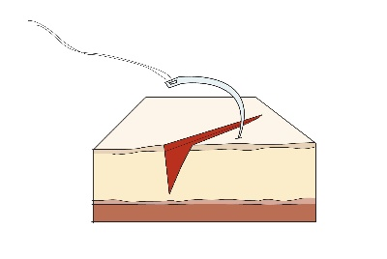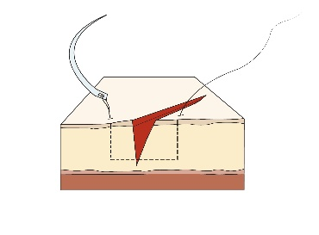
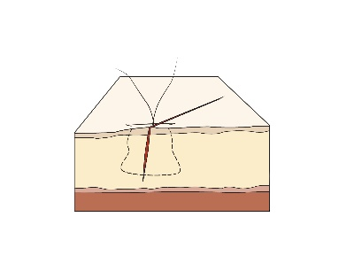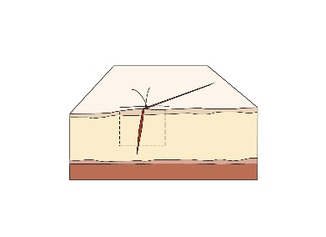
Simple Continuous

Indications
- Running sutures are useful for long wounds in which wound tension has been minimized with properly placed deep sutures and in which approximation of the wound edges is good. This
type of suture may also be used to secure a split- or full-thickness skin graft. Theoretically, less scarring occurs with running sutures compared with interrupted sutures because fewer knots are made with simple running sutures; however, the number of needle insertions remains the same. The major advantage of running sutures is that they can be placed quickly with more rapid reapproximation of wound edges.

Disadvantages
- Risk of dehiscence if the suture material ruptures, difficulty in making fine adjustments along the suture line, and puckering of the suture line when the stitches are placed in thin skin.

Procedure:
- Create a sterile field.
- Administer local anesthetic.
- Thoroughly cleanse wound.
- Start by placing a simple interrupted stitch. Tie the stitch by performing an instrument tie. DO NOT cut the suture.
- Place a series of simple sutures in succession without tying or cutting the suture material after each pass. Sutures should be evenly spaced, and tension should be evenly distributed along the suture line.
- When you reach the end of the wound, do not pull the next-to-last stitch all the way through: leave it as a loop.
- Perform an instrument tie to secure the suture using the loop of the suture as one end.

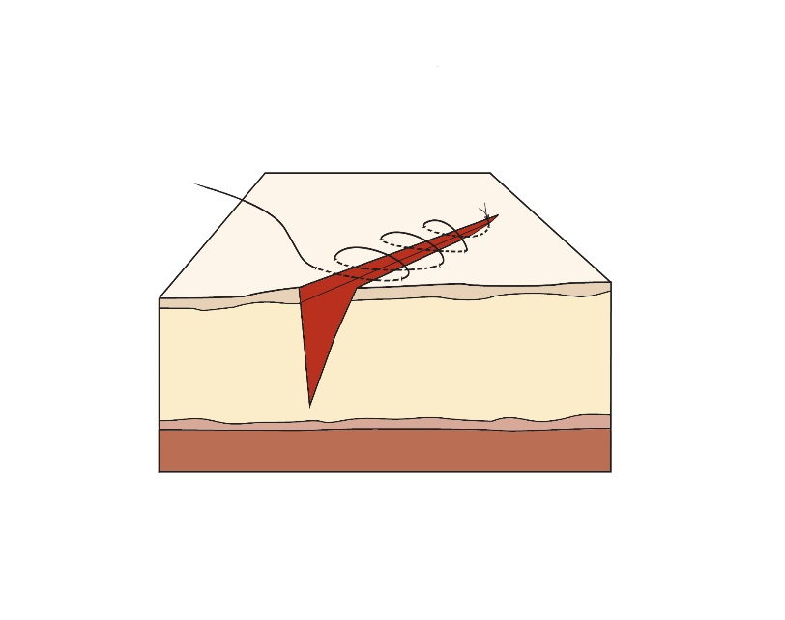

Running subcutaneous/subcuticular sutures
Indications
- The running subcutaneous or subcuticular suture is used to close the deep portion of surgical defects under moderate tension. It is used in place of buried dermal sutures in large wounds when a quick closure is desired. Absorbable suture is often used however, non-absorbable suture may also be used for subcuticular suturing.
Disadvantages
- Risk of suture breakage and the formation of dead space beneath the skin surface.

Procedure
- Create a sterile field.
- Administer local anesthetic.
- Thoroughly cleanse wound.
- Begin with a simple interrupted subcutaneous suture, which is tied but not cut.
- Loop the suture through the opposite side of the wound staying within the subcutaneous tissue.
- When you reach the end of the wound, do not pull the next-to-last stitch all the way through: leave it as a loop.
- Perform an instrument tie to secure the suture using the loop of the suture as one end.
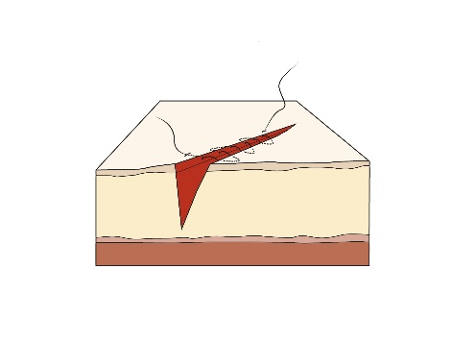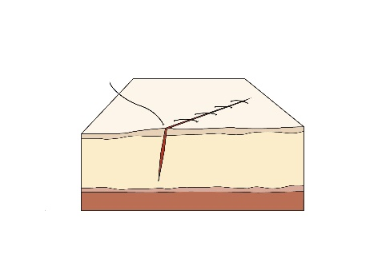
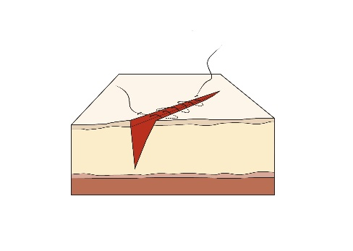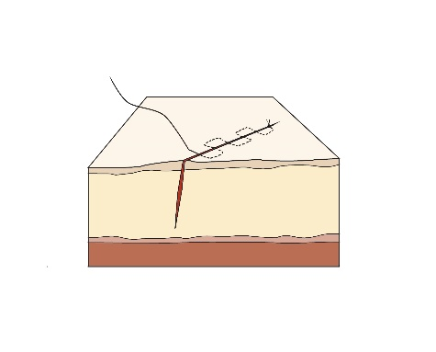

Suture removal

- Sutures should be removed within 1-2 weeks of their placement, depending on the anatomic location. Prompt removal reduces the risk of suture marks, infection, and tissue reaction. The average wound usually achieves approximately 8% of its expected tensile strength 1-2 weeks after surgery. To prevent dehiscence and spread of the scar, sutures should not be removed too soon.
- As a general rule, the greater the tension across a wound, the longer the sutures should remain in place. As a guide, on the face, sutures should be removed in 5-7 days; on the neck, 7 days; on the scalp, 10 days; on the trunk and upper extremities, 10-14 days; and on the lower extremities, 14-21 days. Sutures in wounds under greater tension may need to be left in place slightly longer. Buried sutures, which are placed with absorbable suture material, are left in place because they dissolve.
- Proper suture removal technique is important to maintain good results after sutures are properly selected and executed.
- The time for removal is delayed in patients with conditions that may impair wound healing (i.e. steroids, immunosuppression).
Procedure
- Cleanse the area with an antiseptic. Saline can be used to remove serum encrusted around the sutures.
- Pick up one end of the suture with forceps and cut as close to the skin as possible where the suture enters the skin.
- Gently pull the suture strand out through the side opposite the knot with the forceps. To prevent risk of infection, the suture should be removed without pulling any portion that has been outside the skin back through the skin.
- Steri-Strips may be applied with a tissue adhesive to provide continued supplemental wound support after the sutures are removed.
- Pitfalls to avoid:
Do not cut the suture at two points. Doing this may leave the rest of the material embedded in the skin.
Do not pull the suture away from the incision. This could separate the wound edges and disrupt the epithelization.

